Exo 5.
Student: Umargaliyeva Leila
Problem 1 (Graph and Tree Definitions, 5/10 pts). Prove that the following definitions are
all equivalent:

I want to show these 7 words mean the same thing.
My plan: show 1 goes to 2, 2 goes to 3, & this goes on, till 7 leads to 1 again.

Step 1→2: One piece & no round paths → A part of a group with no rounds
If I have a thing that is all in one piece & has no round path, then it is in a group with no rounds.
The group with no rounds is called a "forest".
If my thing is all in one piece, it is just one part of that group.

Step 2→3: A part of a forest → All in one piece & has most V-1 lines
Look at a tree in this no-round group.
I want to show the tree can't have more lines than V-1. Why? I look at the number of points.
If one point: we have zero lines.
Zero is less than or same as one minus one.
This works.

If we have V points:
Find a point at the end, one line in.
Take it away, with the line.
Now we have V-1 points & E-1 lines.
By the first idea, E-1 is less than or same as (V-1)-1, so E is less than or same as V-1.
This works.

Step 3→4: All in one piece with at most V-1 lines → Can't take out a line
Here is the key:
To keep all in one piece, we need at least V-1 lines.
Ours has at most V-1, so it has just V-1.
If we cut any line, we drop down to V-2 lines.
That is not enough to keep V points all linked.
So it breaks if I take out any line.
A connected group with no round path & V points will always have just V−1 lines
To connect V vertices starting from one vertex, each new vertex needs at least one new edge, so any connected graph must have at least V−1 edges.

Step 4→5: Can't take out lines → No round path, with at least V-1 lines
Think of this: maybe there is a round path.
I could cut one line from this round, & still go from one end to the same end, by the other way around.
But this does not work, as I can't cut *any* line.
So round paths can't be there.
A group with no round path & V points, will always have just V-1 lines.
So it has at least V-1 lines.

Step 5→6: No round path with at least V-1 lines → Can't add lines
We know groups with no round path can't have more than V-1 lines.
Ours has at least V-1.
That means it has just V-1 lines.
So it is all linked as one.
Now, can I add a line?
If I try to make a new line between any two points, those two are already linked, by a path.
Adding this new line gives another way between these points, making a round path.

Step 6→7: Can't add lines → Only one way to go between points
Our group is all in one piece.
If it was in parts, I could draw a line between these parts, & would not make a round path.
Between any two points, there is a way to go, as it's all one piece.
Can there be two ways between two points?
No.
If I have two ways, that would make a round path.
But we can't have that.
So, there is only one way to go between each pair of points.

Step 7→1: Only one way → All in one piece, no rounds
If there is only one way between points, it is all one group.
Can there be a round path?
Think like this:
If there was a round path: take v₁, v₂, ... vₖ, back to v₁.
I can go from v₁ to v₂ two ways:
Go the fast way: v₁ to v₂.
Go the long way: v₁, vₖ, back, all the way to v₂.
Now, I have two ways from v₁ to v₂!
That can't be, as we said only one way is there.
So, no round path can be here.
All in one piece & no rounds = we are back at start.

Problem 2 (Sparse representation of graphs, 5/10 pts). Given the following CSC (Compressed
Sparse Column) representations for two graphs on vertices {A, B, C, D, E}(indexed as A →0,
B →1, C →2, D →3, E →4):

Graph 1 (Undirected)

Vertices: A (0), B (1), C (2), D (3), E (4)
Graph 1 (undirected):
col_pointers = [0, 2, 5, 8, 11, 12]
row_indices = [1, 2, 0, 2, 3, 0, 1, 3, 1, 2, 4, 3]
values = [1, 1, 1, 1, 1, 1, 1, 1, 1, 1, 1, 1]

The grid is the same both ways for a graph with no set path. Rows match to A, B, C, D, & E. Columns match to A, B, C, D, & E too.
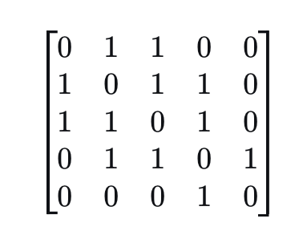
The graph has nodes: A, B, C, D, E. Lines are: A-B, A-C, B-C, B-D, C-D, D-E. A, B & C make a small loop. D goes to both B & C. E is joined just to D. So, A-B-C is one shape, D joins B & C, E links to D. Each part links close. The end is E.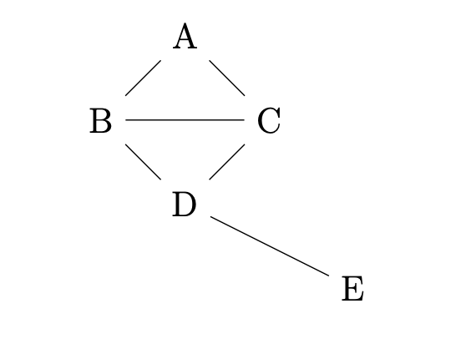

Graph 2 (Directed)

col_pointers = [0, 0, 2, 4, 5, 7]
row_indices = [0, 3, 0, 1, 2, 1, 3]
values = [1, 1, 1, 1, 1, 1, 1]

The matrix is not the same on both sides. It is for a graph with lines that show which way you go. Rows show where lines start. Columns show where lines end.
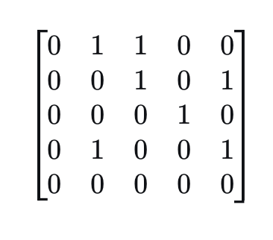
The chart has points A, B, C, D, E. Lines go: A to B, A to C, B to C, B to E, C to D, D to B, D to E. Point E has no lines out. No lines go from E.
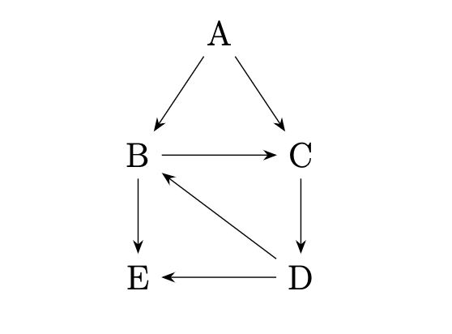
The unique cycle in the directed graph is: B → C → D → B.

